NAME: GEOFFREY MUSILI MWANIKI

REGNO: I225/T/6417/23

COMPUTER PROGRAMMING CAT 2

1. **What is program documentation and enumerate four advantages associated with it . [4marks]**

Program documentation refers to written text or illustrations that accompany computer software to explain how it works or how to use it.

Advantages:

Facilitates program maintenance and updates

Helps new programmers understand the code

Provides reference for future modifications

Explains complex algorithms or logic

Documents program requirements and specifications

1. **Write a program in java to demonstrate the use of switch statements. [4 marks]**

import java.util.Scanner;

public class SwitchDemo {

public static void main(String[] args) {

Scanner input = new Scanner(System.in);

System.out.println("Enter day number (1-7):");

int day = input.nextInt();

switch(day) {

case 1:

System.out.println("Monday");

break;

case 2:

System.out.println("Tuesday");

break;

case 3:

System.out.println("Wednesday");

break;

case 4:

System.out.println("Thursday");

break;

case 5:

System.out.println("Friday");

break;

case 6:

System.out.println("Saturday");

break;

case 7:

System.out.println("Sunday");

break;

default:

System.out.println("Invalid day number");

}

}

}

1. **Explain how throw and catch are used in exceptional handling . [4 marks]**

throw: Used to explicitly raise an exception in code when an error condition occurs

Example:

throw new ArithmeticException("Division by zero");

catch: Used to handle exceptions that are thrown in the try block

example:

try {

// code that might throw exception

} catch (ExceptionType e) {

// handle exception

}

1. **Explain the following four fundamental principles of object oriented programming . [8marks]**

i. Abstraction

Showing only essential features while hiding implementation details

Example: Car dashboard shows speed but hides engine mechanics

ii. Inheritance

Creating new classes from existing ones, inheriting their properties

Example: Dog class inherits from Animal class

iii. Encapsulation

Bundling data and methods that operate on that data within one unit

Example: Class with private variables and public methods

iv. Class and Object

Class: Blueprint/template for creating objects (defines properties and behaviors)

Object: Instance of a class with actual values

Example: Car is class, myToyota is object

1. **Using a block diagram explain the following control structures in C programming**

i. Sequence logic structure

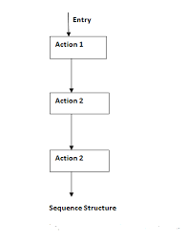

ii. Decision logic structure

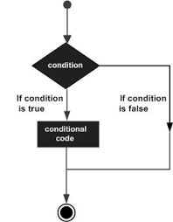

iii. Loop structure [6 marks]

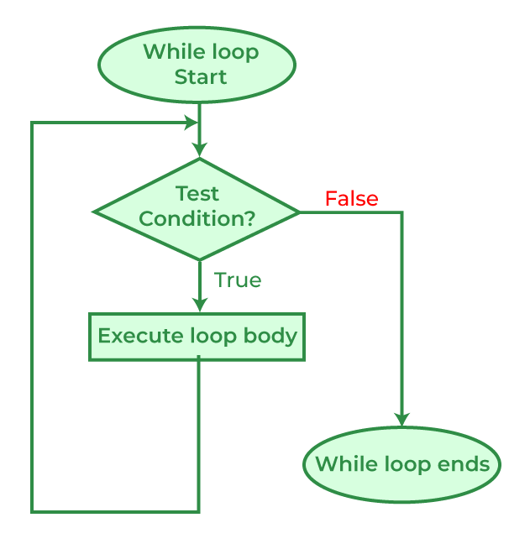

1. **Explain the structure of C programing language [2 marks]**

Preprocessor directives (#include, #define)

Global declarations (variables, functions)

main() function (program entry point)

Function definitions

Comments

1. **Explain any four characteristics of an algorithm [2 marks]**

Input: Should have zero or more well-defined inputs

Output: Must produce at least one output

Definiteness: Each step must be clear and unambiguous

Finiteness: Must terminate after finite number of steps

Effectiveness: Each step must be basic enough to be carried out